AL ZADID YUSUF

Student ID: 103148592

DUE DATE: 04/09/2024

SUBMISSION DATE: 04/09/2024

TARGET GRADE: HD

Deployment task 3

2024-HS2-SWE40006-Software Deployment and Evolution

Table of Contents

Task 3.1 2

Create Azure account 2

Install visual Studio 2

Deploy any existing app to cloud via Azure 3

Link for the Web App 6

Task 3.2 6

Develop C# app 6

Deploy your app to cloud via Azure 7

Deactivate the app 8

Task 3.3 9

Install PHP 9

Develop a web app 10

Brief Description of the Online Grocery Store web app itself 10

Deploy app to cloud via Azure 16

Link for the Web App 18

# Task 3.1

## Create Azure account

I have created an Azure account as shown in figure 1, which provides access to a wide range of cloud services and resources. This setup is essential for deploying and managing applications in a scalable and secure cloud environment.

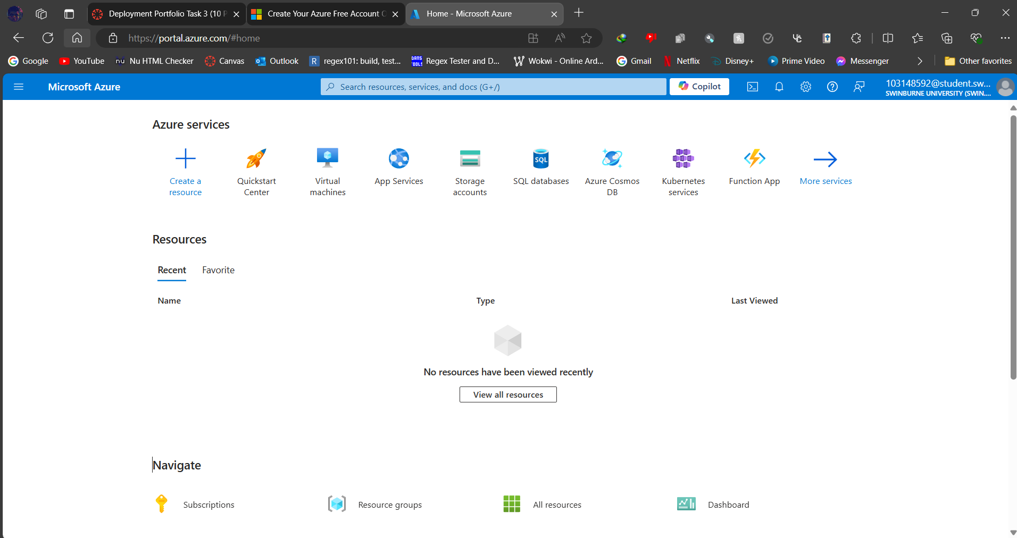

Figure 1: Azure Portal after successful creation of an account

## Install visual Studio

I have installed Visual Studio 2017, a comprehensive integrated development environment (IDE) that supports various programming languages. This tool will be used for developing, testing, and deploying applications directly to the Azure cloud.

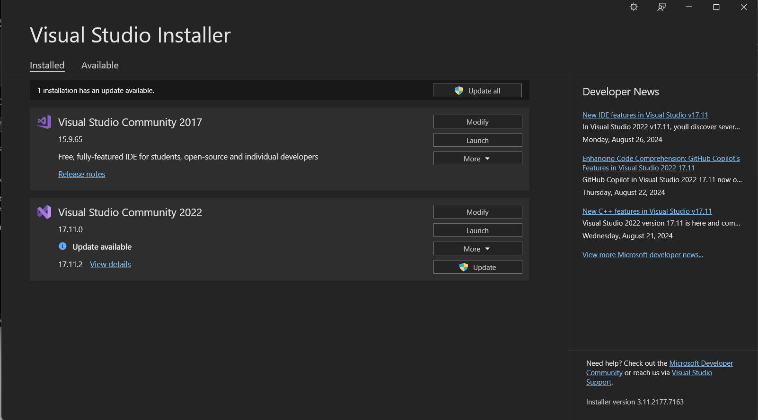

Figure 2: Successful Installation of Visual Studio 2017

## Deploy any existing app to cloud via Azure

I have successfully deployed a sample application provided by the Visual Studio to Azure, utilizing the platform's robust cloud infrastructure. This deployment process involved configuring the app's resources and ensuring it is accessible and functional in the cloud environment.

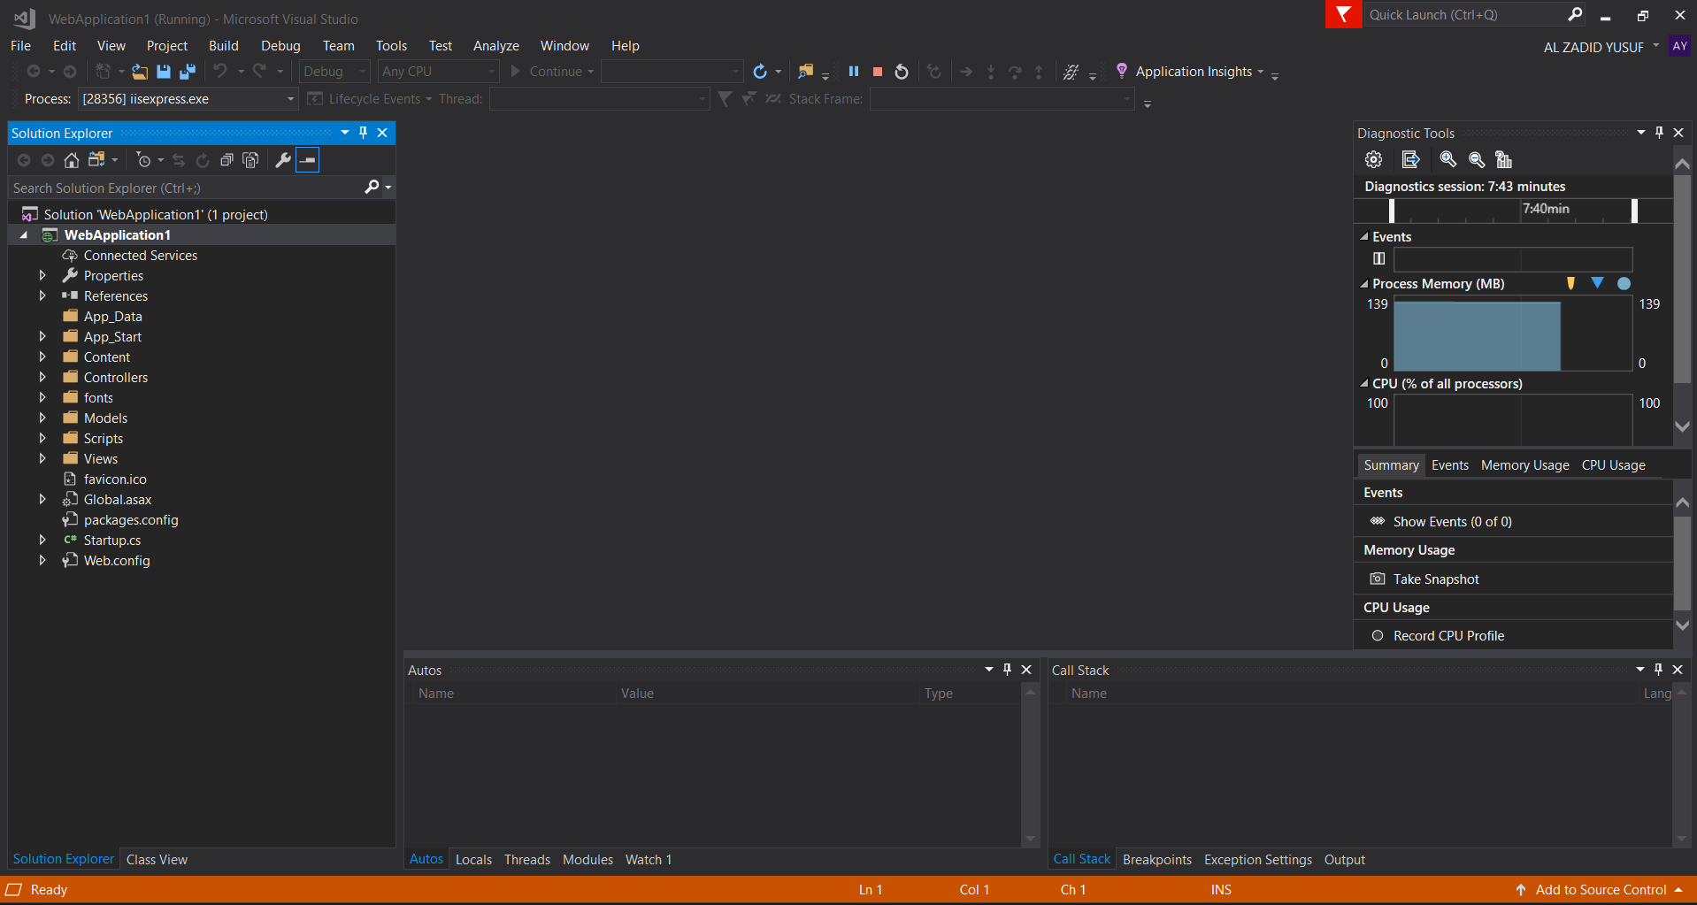

Figure 3: Successful deployment of ASP.Net Web Application into localhost

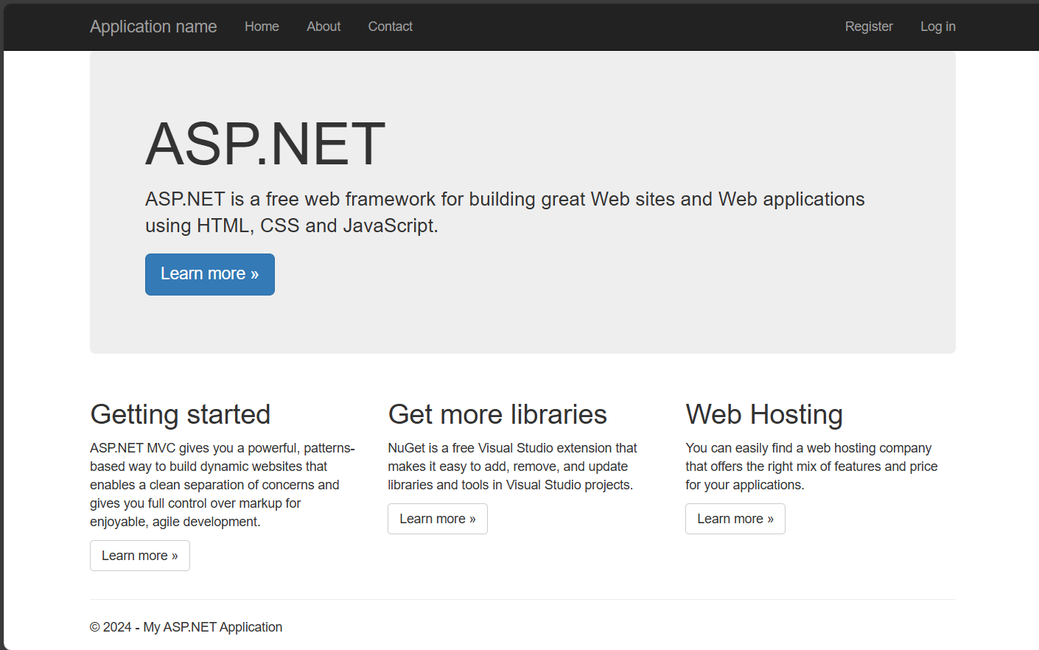

Figure 4: Successful deployment of ASP.Net Web Application into localhost

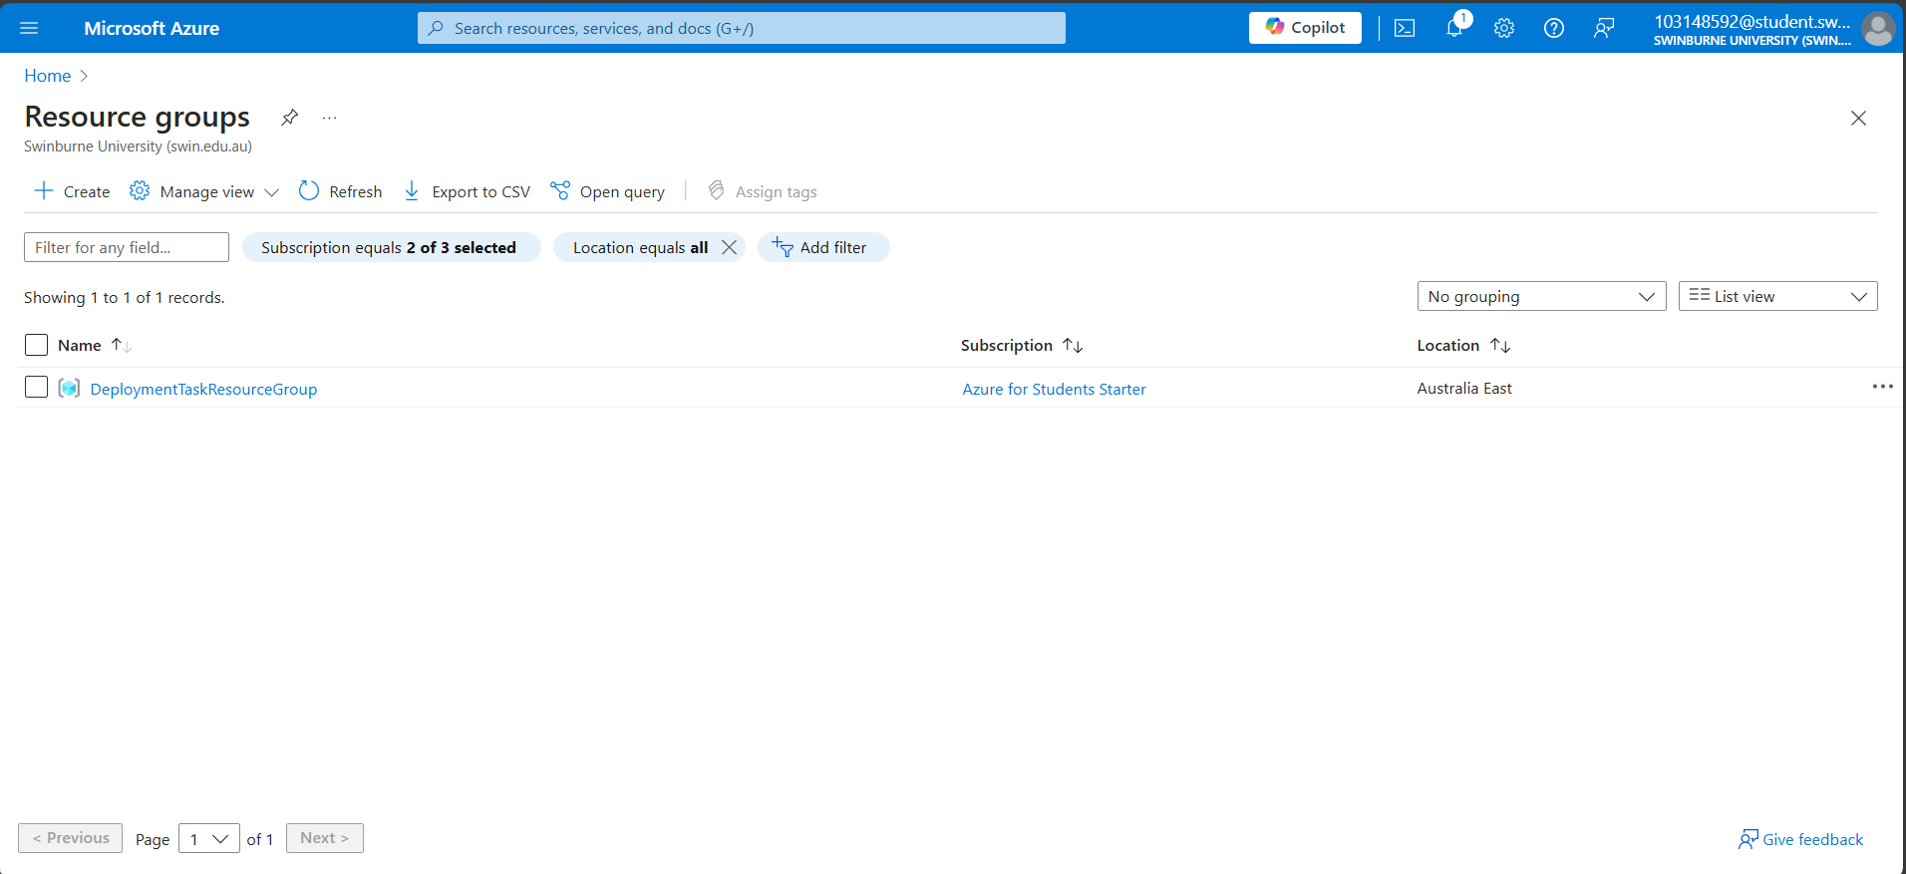

Figure 5: Successful creation of Resource Group in Azure Portal

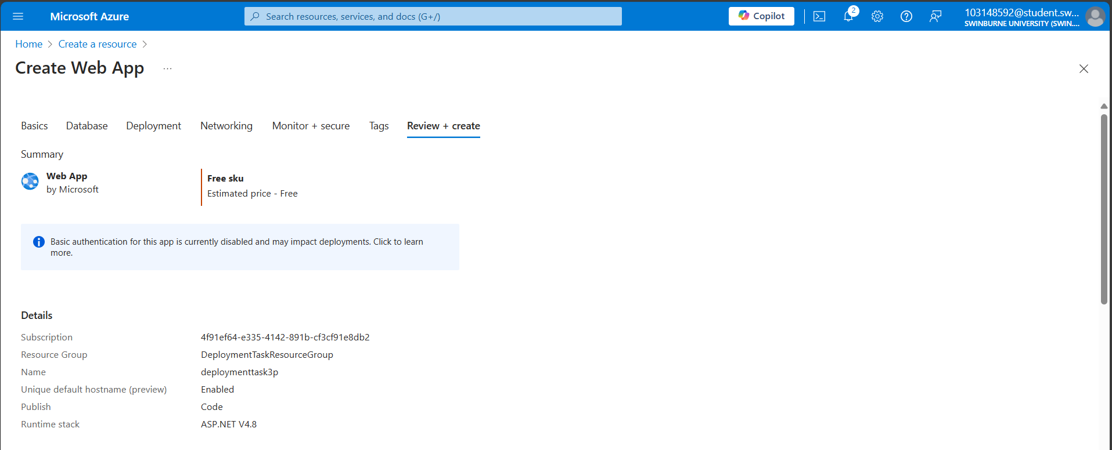

Figure 6: Successful Creation of Web App into Azure

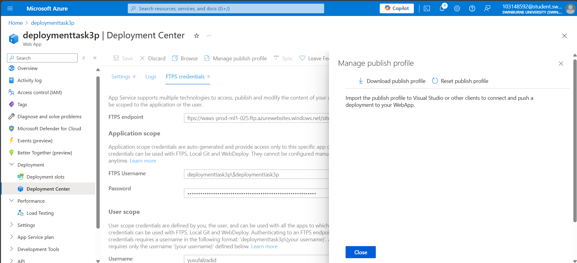

Figure 7: Downloading the publish profile for deployment into Azure using VS

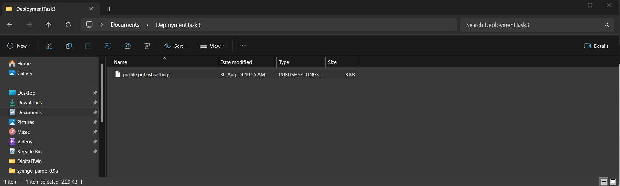

Figure 8: Location of the downloaded publish profile inside local machine

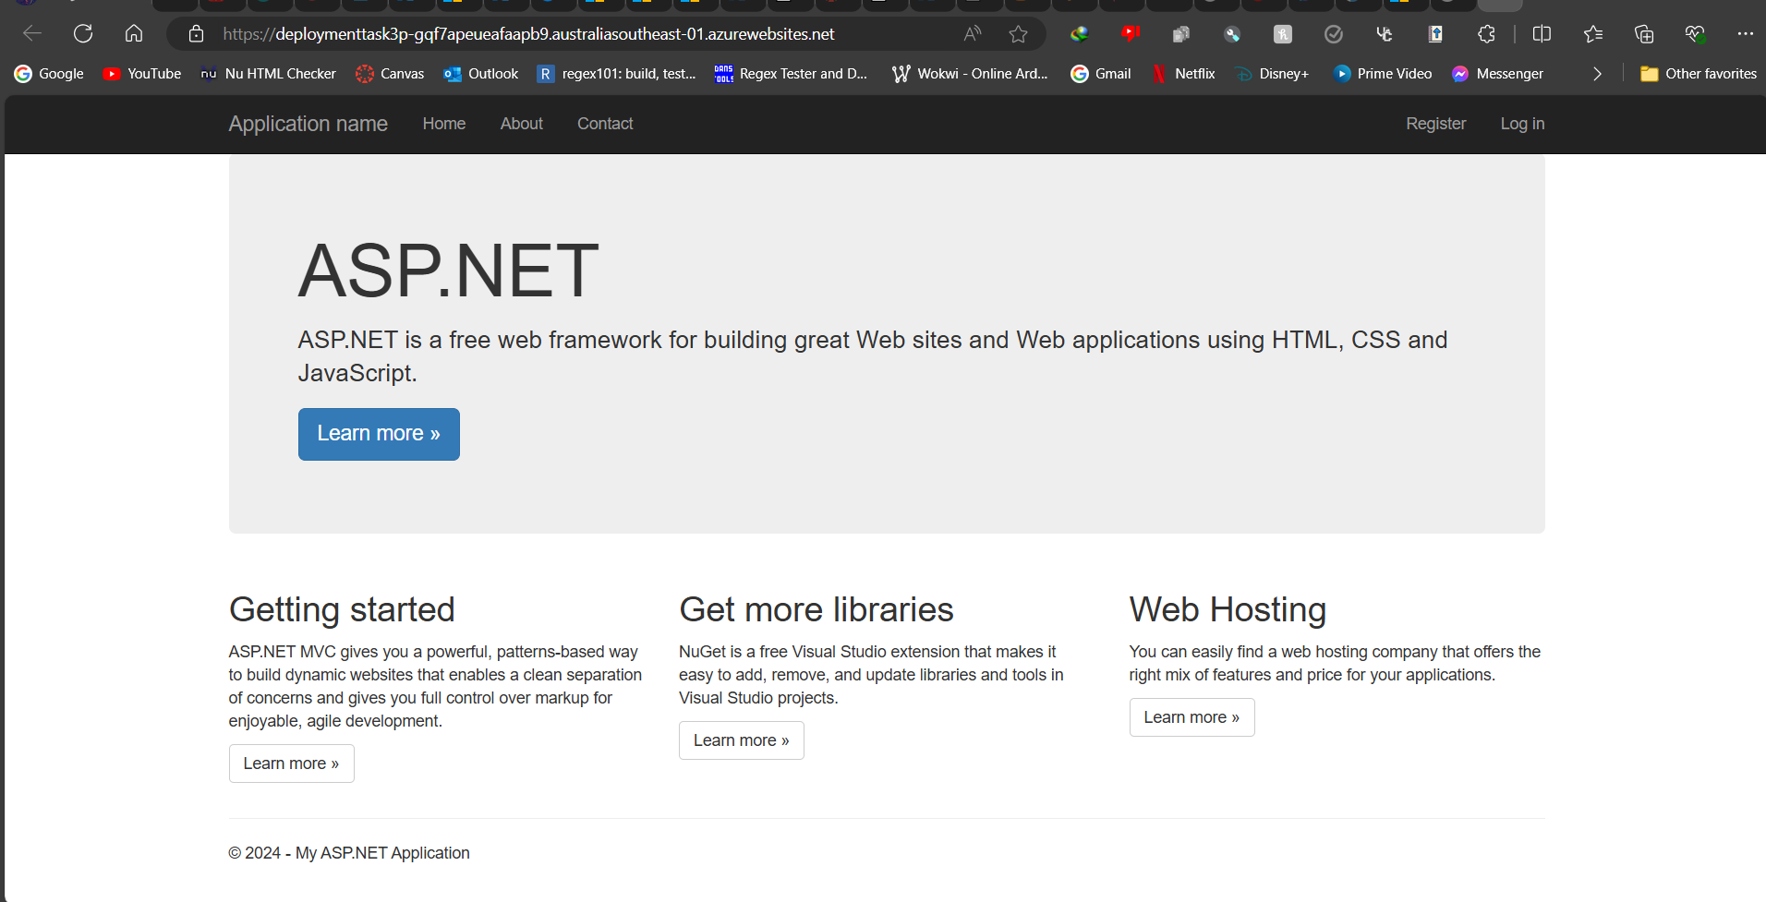

Figure 9: Successful deployment of ASP.Net Web Application into Azure

### Link for the Web App

<https://deploymenttask3p-gqf7apeueafaapb9.australiasoutheast-01.azurewebsites.net/>

# Task 3.2

## Develop C# app

I have developed a Simple Calculator Web app using C#. This application allows users to perform basic arithmetic operations such as addition, subtraction, multiplication, and division. The app's interface is designed to be intuitive and user-friendly, ensuring easy access to its functionalities.

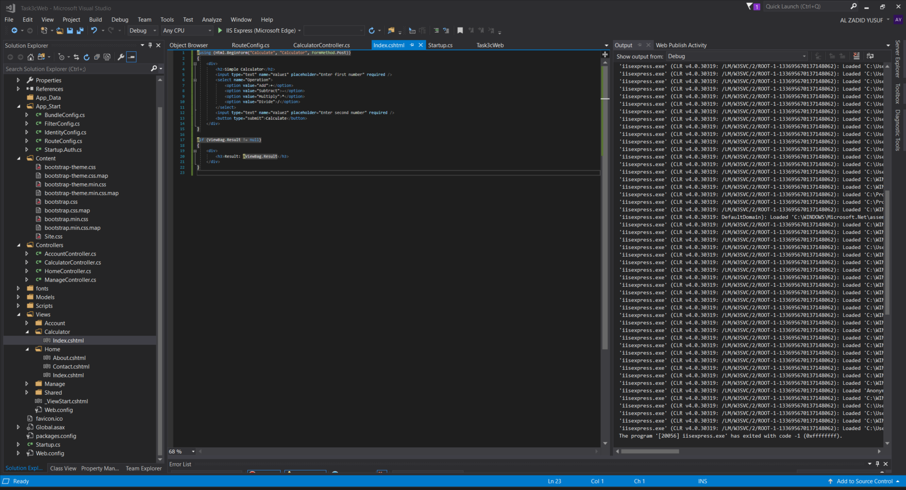

Figure 10: Configuration of index.cshtml file for the Simple Calculator Web App

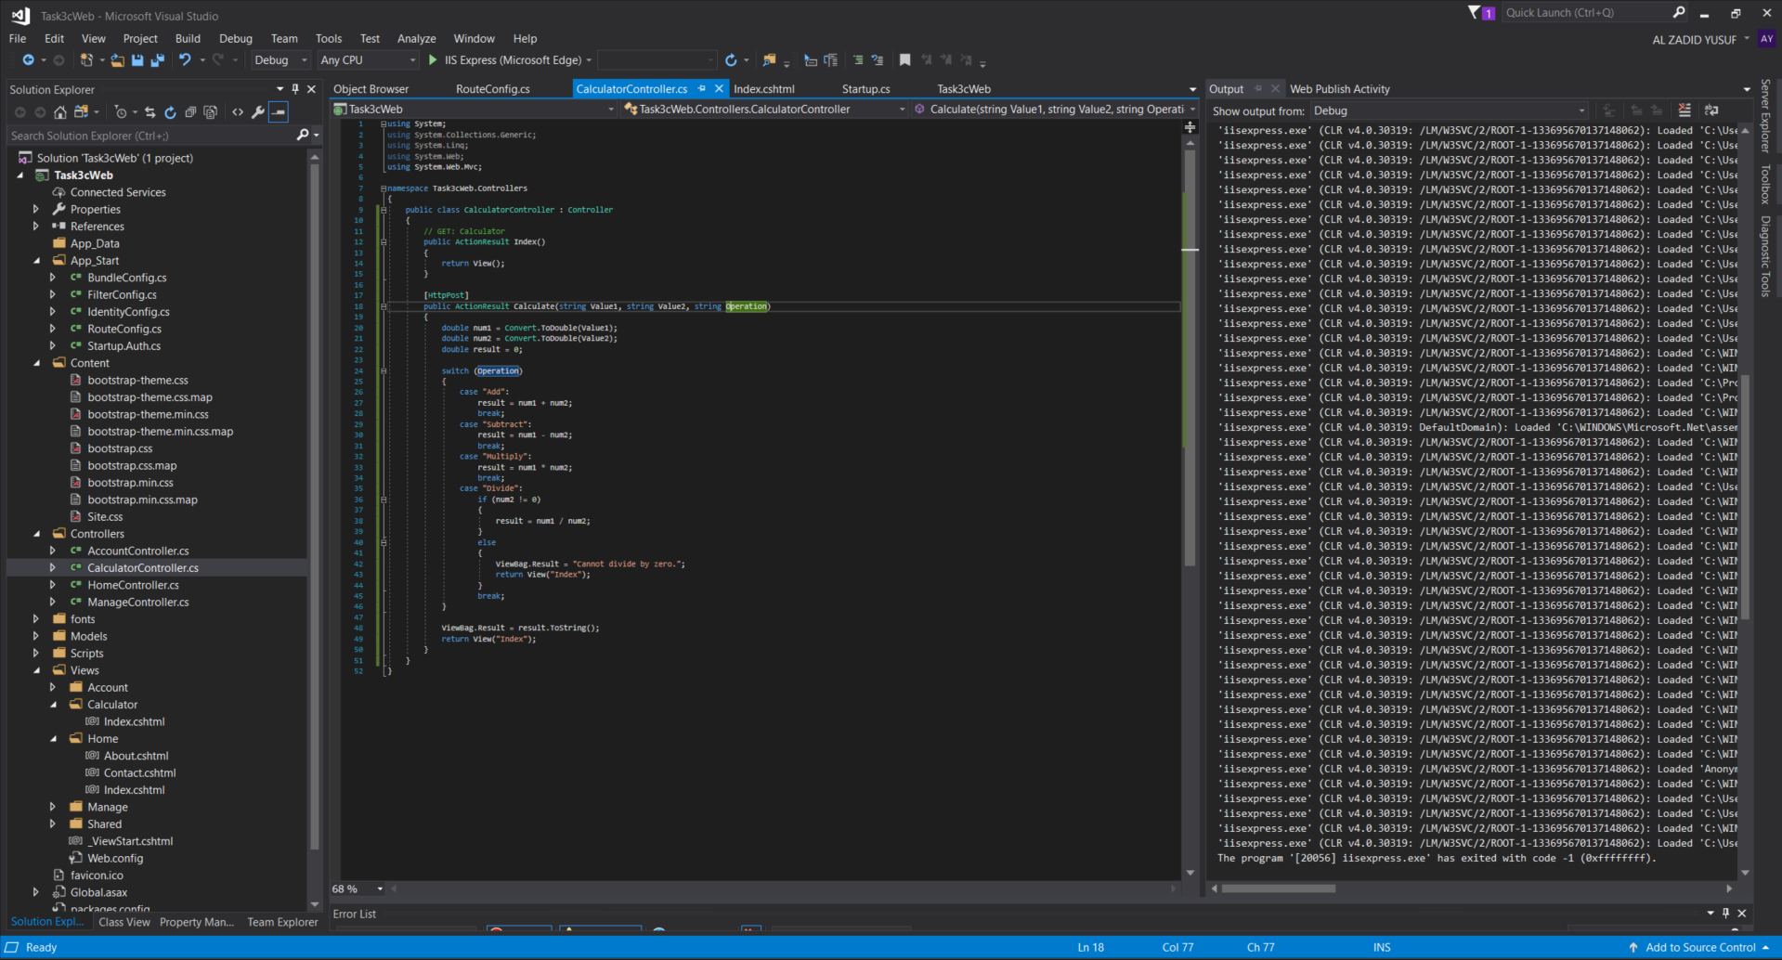

Figure 11: Configuration of the CalculatorController.cs file delegated for handing calculations of the Simple Calculator Web App

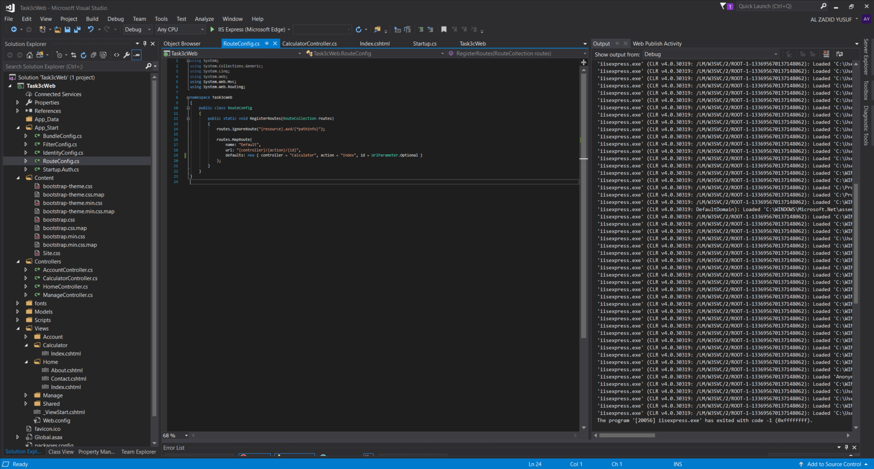

Figure 12: Configuration of the RouterConfig.cs file for the project

## Deploy your app to cloud via Azure

I have deployed the Simple Calculator Web app to Azure, making it accessible online. This deployment included configuring the necessary cloud resources, such as the web server and hosting environment, to ensure the app runs efficiently and is available to users.

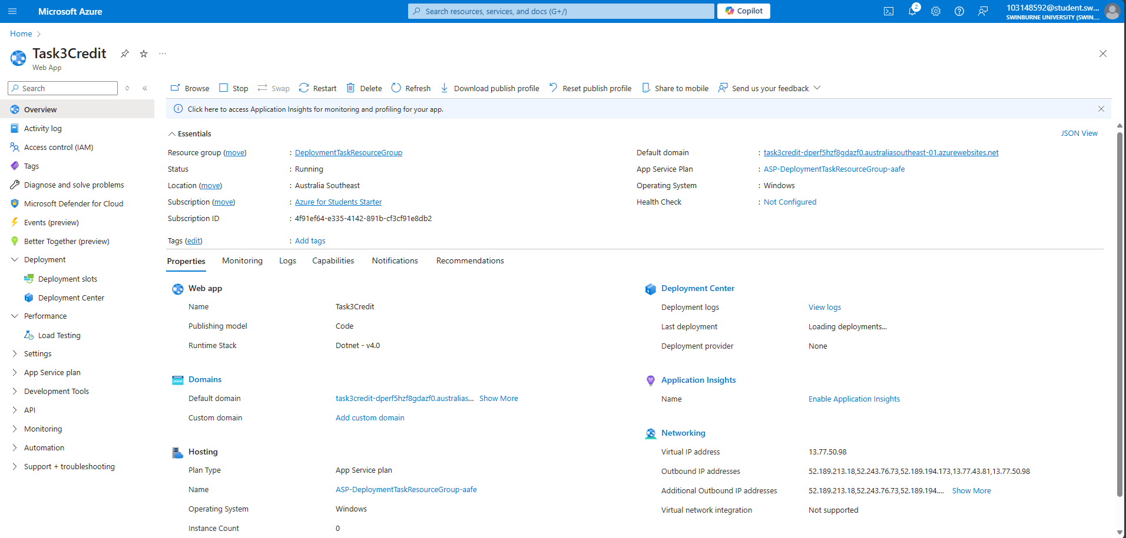

Figure 13: Successful creation of the Web App inside Azure

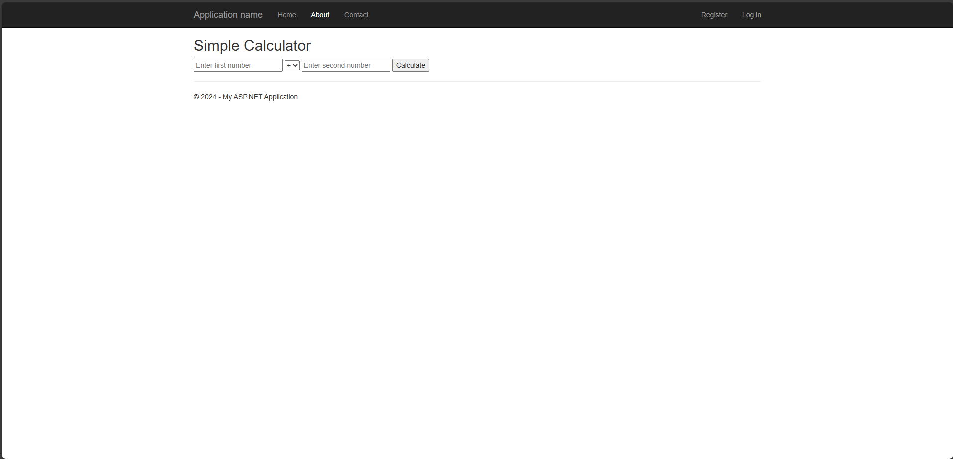

Figure 14: Successful Deployment of Simple Calculator Web App into Azure

## Deactivate the app

I have deactivated the Simple Calculator Web app on Azure to manage cloud resources effectively. This involved stopping the app's services, ensuring no further resource consumption while the app is inactive.

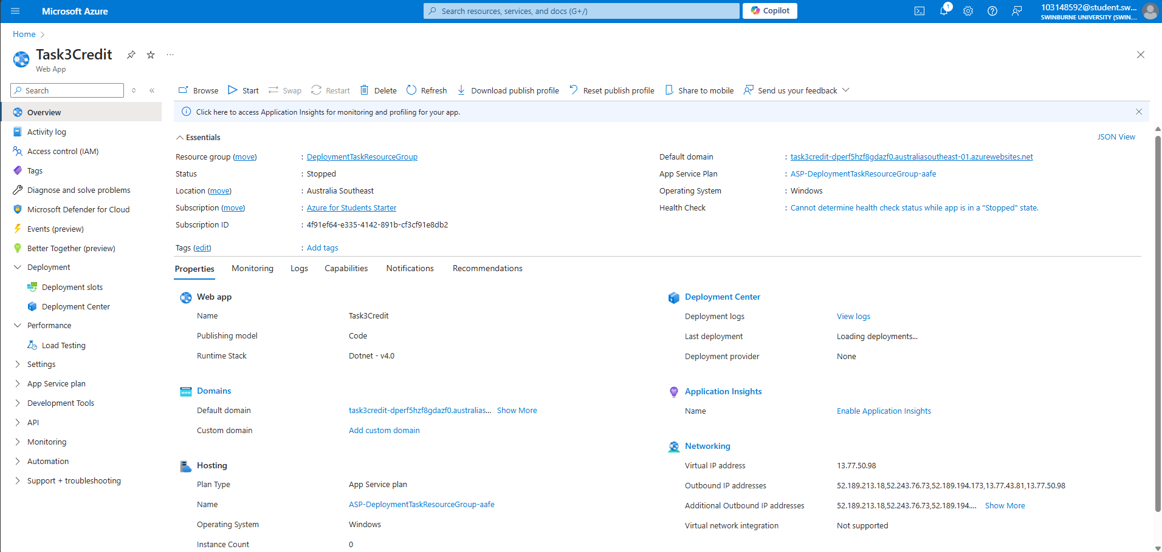

Figure 15: Successful Deactivation of the SImple Calculator Web App

# Task 3.3

## Install PHP

I have installed PHP, enabling the development of dynamic web applications. This setup provides the necessary environment to build and run server-side scripts, essential for creating interactive web experiences.

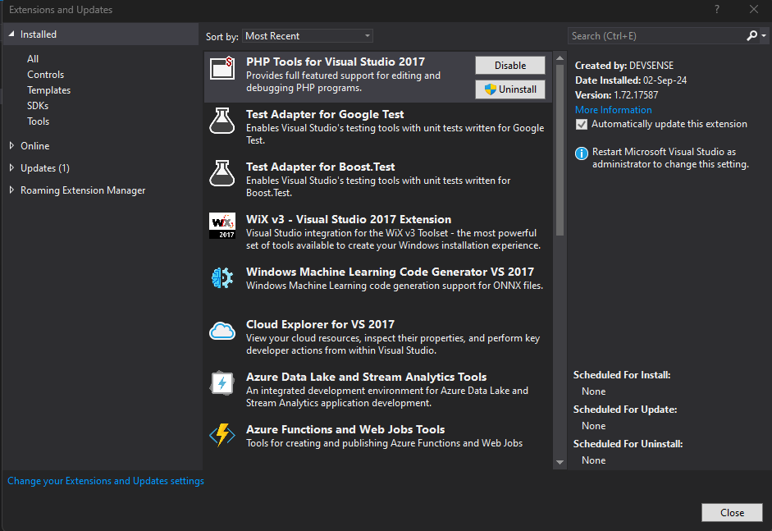

Figure 16: Successful installation of the PHP Tools for Visual Studio 2017

## Develop a web app

I have developed an Online Grocery Store Web app using PHP. This application allows users to browse various grocery products, add items to their cart, and proceed to checkout. The app features a modern and responsive design, making it easy for users to navigate through categories, search for products, and manage their shopping cart. For this web app itself, several scripts from Bootstrap, J

### Brief Description of the Online Grocery Store web app itself

**1. index.php:**

The index.php file serves as the homepage of your Online Grocery Store. It provides users with an overview of the site, including a hero section with a promotional message and links to popular product categories like Fresh Vegetables, Fresh Fruits, Dairy Products, and Snacks. The page is designed to be visually appealing, with hover effects and animations that enhance user interaction.

**Key Components:**

* **Hero Section:** Contains a background image with a faint black overlay and a call-to-action button for users to start shopping.
* **Categories Section:** Displays clickable cards for different product categories, allowing users to browse products by category.
* **Scripts:** Utilizes jQuery, Popper.js, and Bootstrap's JavaScript library to handle responsive design and interactive elements like the navbar toggle.

**2. shop.php:**

The shop.php file lists all the products available in the store, allowing users to browse and select items for purchase. It also includes a search functionality that lets users filter products based on their search queries.

**Key Components:**

* **Product Listing:** Displays each product with its image, name, price, and a link to view more details.
* **Search Functionality:** A search bar in the header filters products dynamically based on user input, enhancing the browsing experience.
* **Scripts:** Similar to index.php, this file uses jQuery, Popper.js, and Bootstrap's JavaScript for the responsive navbar and search functionality.

**3. product.php:**

The product.php file displays detailed information about a specific product, including its image, price, and description. Users can select the quantity they wish to purchase and add the product to their cart.

**Key Components:**

* **Product Details:** Shows the selected product's image, name, price, and quantity selection.
* **Add to Cart:** A form that allows users to specify the quantity and add the item to their shopping cart.
* **Scripts:** Uses Bootstrap's JavaScript and jQuery for handling any interactive elements, ensuring the form submission and navigation work smoothly.

**4. cart.php:**

The cart.php file manages the user's shopping cart, displaying all items added to the cart along with their quantities and total price. Users can update the quantity of each item, remove items, or proceed to checkout.

**Key Components:**

* **Cart Summary:** Lists all products in the cart, showing the quantity and total price for each item.
* **Update and Remove:** Provides options to update the quantity or remove items from the cart.
* **Checkout:** A button that takes users to the checkout process.
* **Scripts:** Uses jQuery and Bootstrap's JavaScript to handle the update and remove actions, as well as to enhance the user interface with responsive elements.

**5. checkout.php:**

The checkout.php file handles the final step of the purchase process, where users can review their cart, enter shipping and payment details, and confirm their order.

**Key Components:**

* **Order Summary:** Displays a final summary of the items in the cart with the total cost.
* **User Details Form:** Allows users to enter their name, address, and payment information.
* **Order Confirmation:** A form that submits the order for processing.
* **Scripts:** Like the other pages, this file includes jQuery and Bootstrap's JavaScript to manage the form interactions and ensure a smooth user experience.

**6. styles.css:**

The styles.css file contains custom CSS to style the web app, including layout, typography, colors, and animations. It ensures the site looks modern and is responsive across different devices.

**Key Components:**

* **Hero Section Styling:** Ensures the text in the hero section is readable with a faint black overlay.
* **Category Hover Effects:** Adds interactive hover effects to category cards.
* **Cart Badge:** Styles the badge showing the total quantity and price in the cart.

**7. Scripts Used Across the App:**

* **jQuery:** A popular JavaScript library that simplifies HTML document traversal, event handling, and animation. It ensures the web app's dynamic elements work smoothly across different browsers.
* **Popper.js:** A library used to position tooltips and popovers in web applications, ensuring that these elements are placed accurately in the UI.
* **Bootstrap's JavaScript:** Provides a range of interactive components like modals, dropdowns, and carousels, which are used to enhance the user interface. Bootstrap's scripts also manage responsive behavior, making the web app adaptable to different screen sizes.

**Summary:**

Together, these PHP files and scripts form the backbone of your Online Grocery Store Web app. The combination of server-side logic (PHP) and client-side interactivity (JavaScript, jQuery, Bootstrap) ensures that users have a seamless shopping experience, from browsing products to completing a purchase. The app's design is further enhanced by custom CSS, which provides a modern and engaging look and feel.

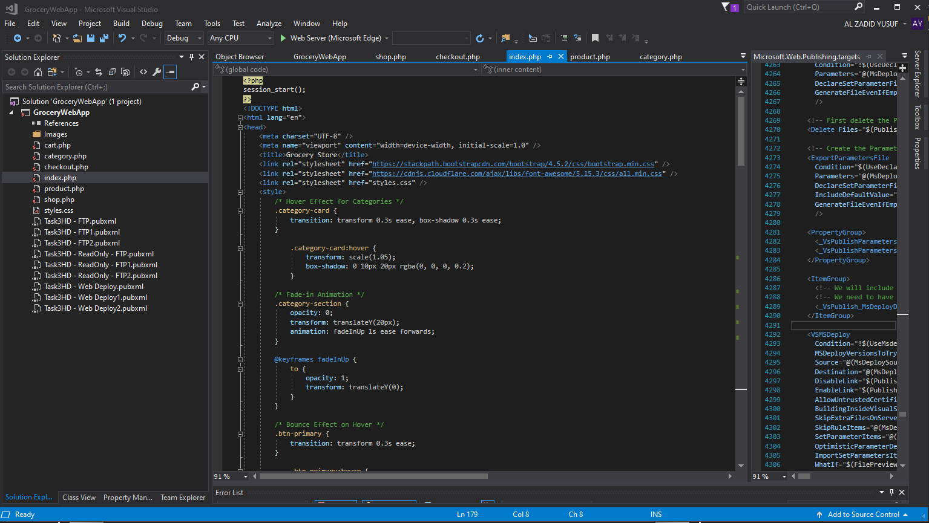

Figure 17: Configuration of the index.php for the Online Grocery Store Web App

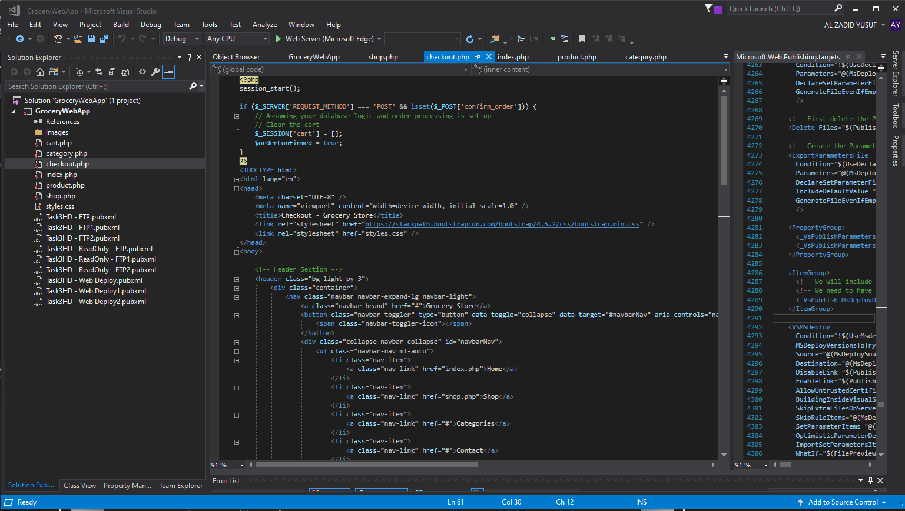

Figure 18: Configuration of the checkout.php for the Online Grocery Store Web App

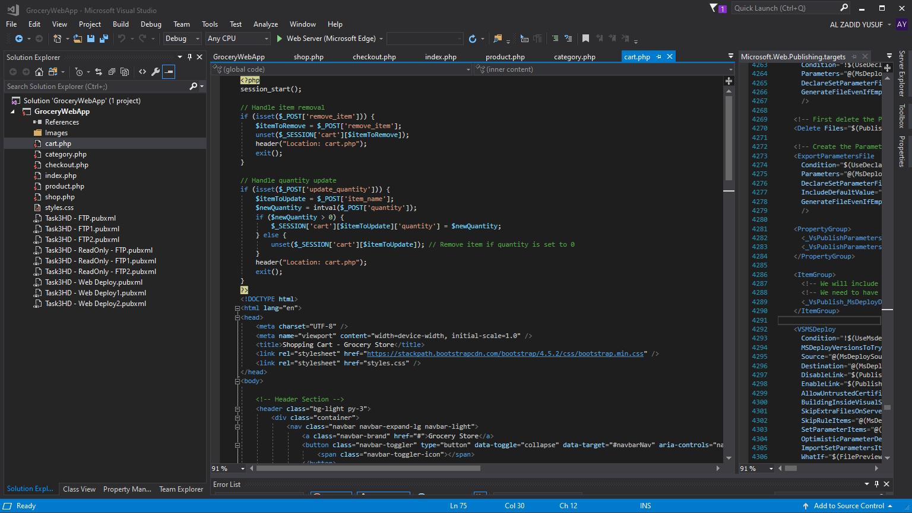

Figure 19: Configuration of the cart.php for the Online Grocery Store Web App

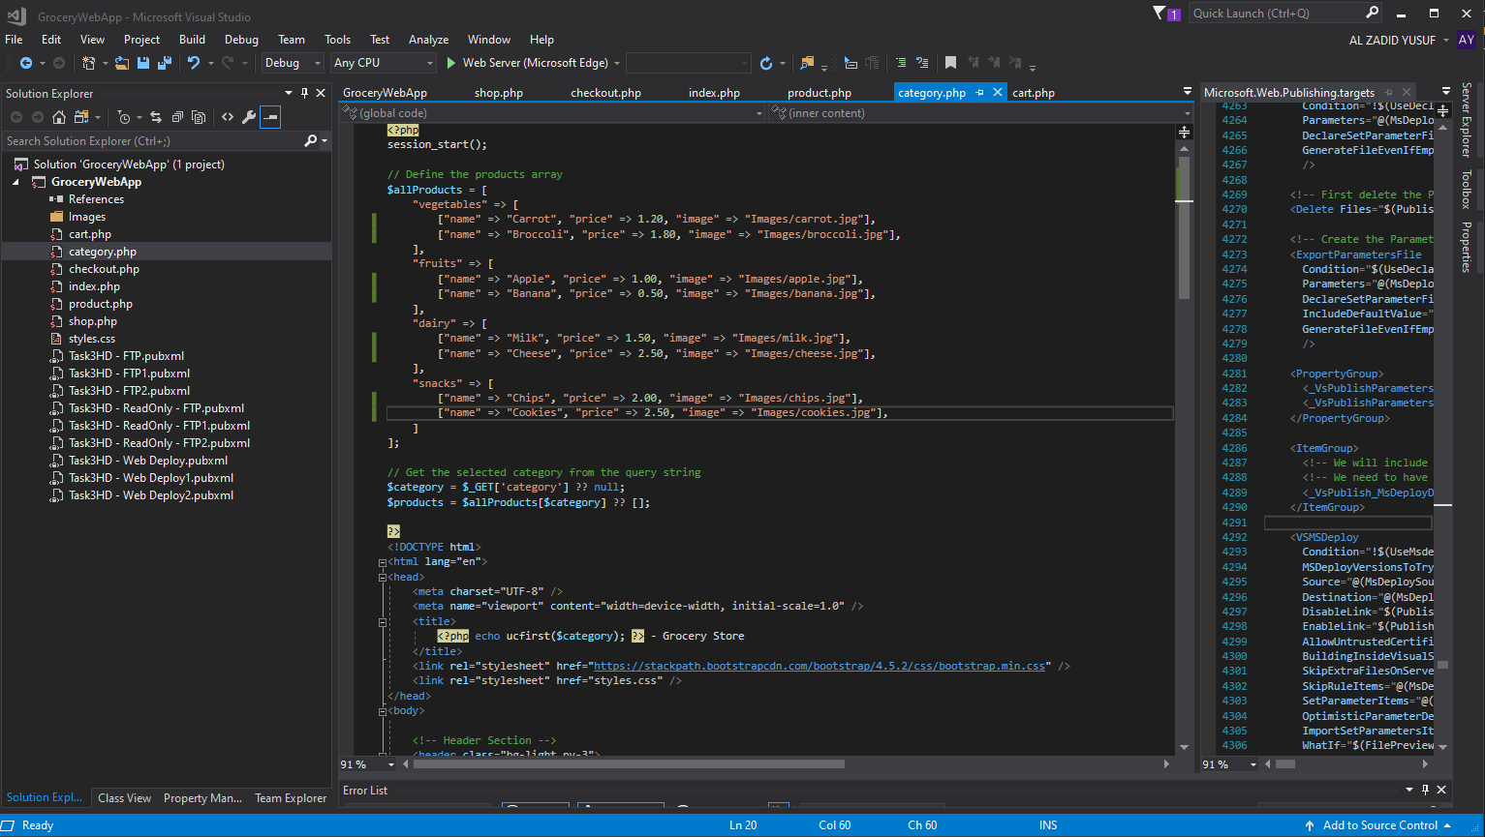

Figure 20: Configuration of the category.php for the Online Grocery Store Web App

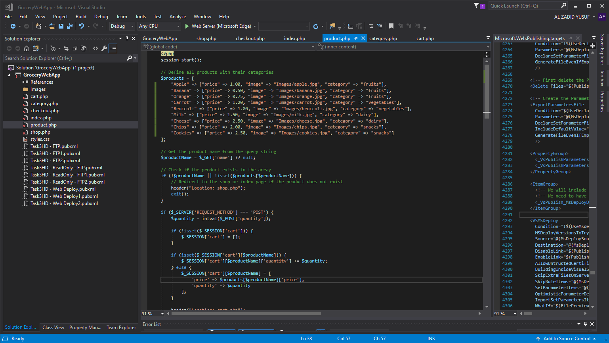

Figure 21: Configuration of the product.php for the Online Grocery Store Web App

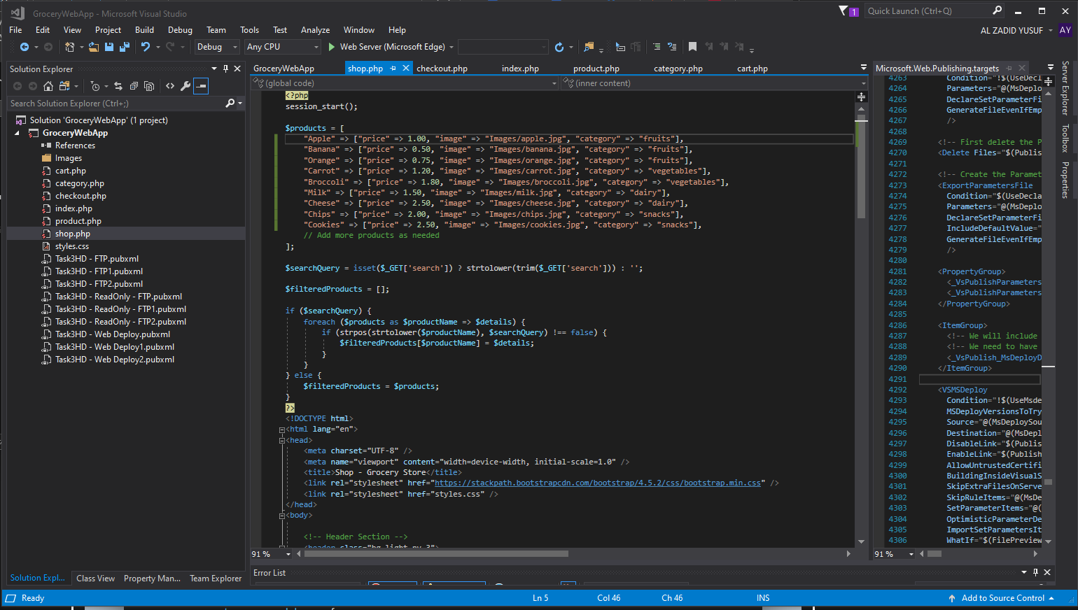

Figure 22: Configuration of the shop.php for the Online Grocery Store Web App

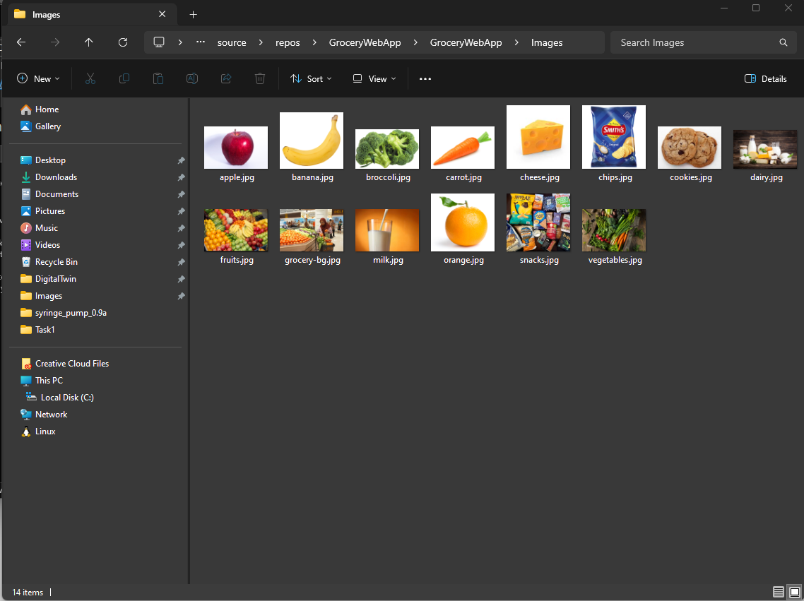

Figure 23: Locations of the asset images being stored in the project

## Deploy app to cloud via Azure

I have deployed the Online Grocery Store Web app to Azure using FTP option, ensuring it is accessible to users via the cloud. The deployment process involved setting up a web server, configuring databases, and optimizing the app for performance and security in a cloud environment.

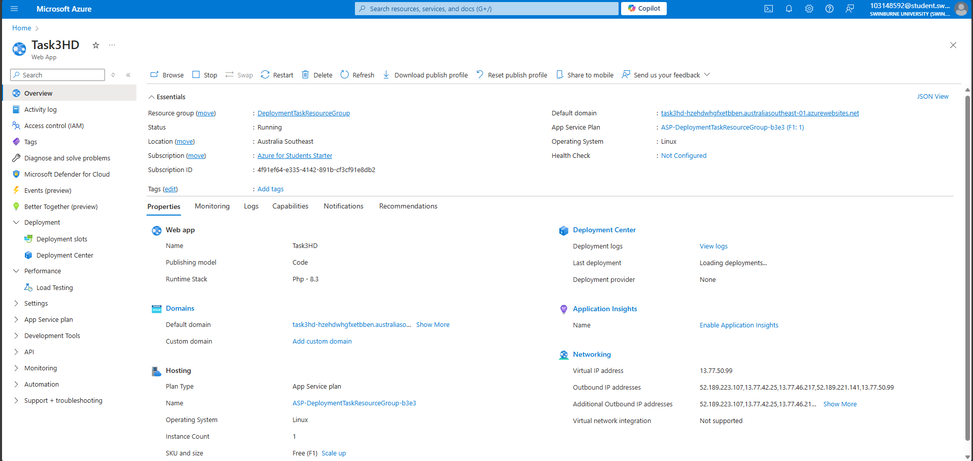

Figure 24: Successful creation of the Web App inside Azure

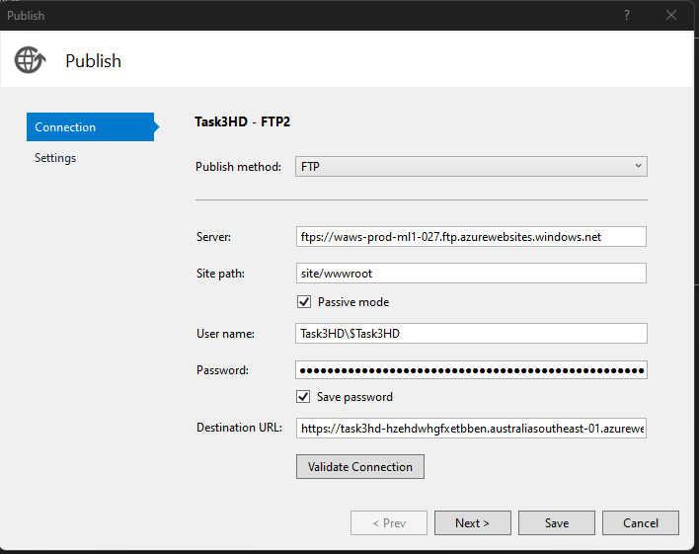

Figure 25: Publish configuration for the successful deployment of the Online Grocery Store Web App into Azure

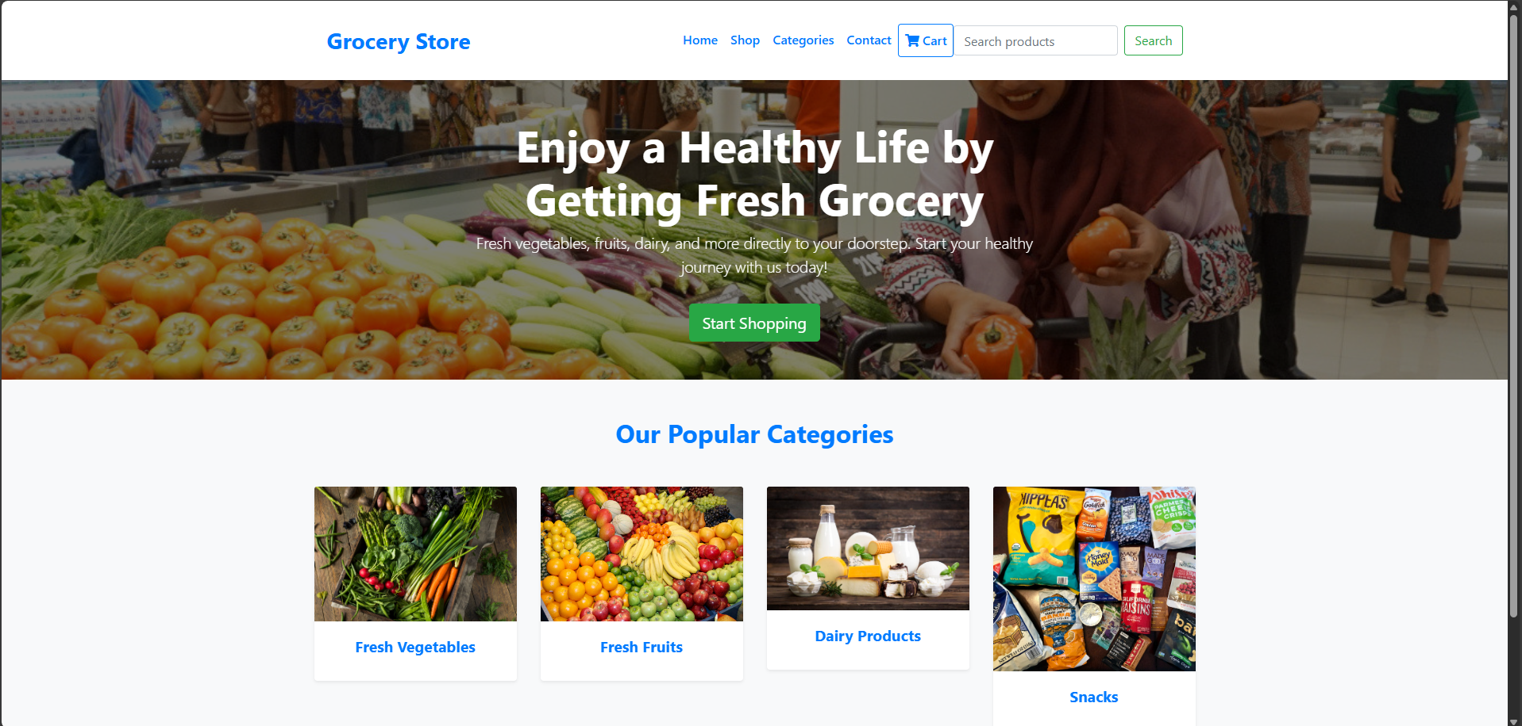

Figure 26: Successful deployment of the Online Grocery Store Web App into Azure

### Link for the Web App

https://task3hd-hzehdwhgfxetbben.australiasoutheast-01.azurewebsites.net/